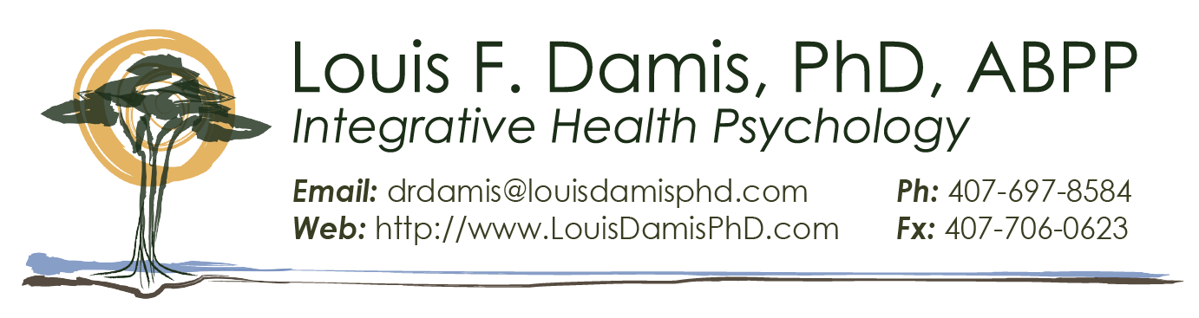

ASCH Approved Advanced Clinical Hypnosis Virtual Workshop
Hypnosis for the Treatment of Developmental Trauma Disorders
Louis F. Damis, Ph.D., ABPP, FASCH
Clinical Hypnosis Society, BC Division
British Columbia, Canada
https://www.hypnosis.bc.ca/

Program Dates/Times

Saturday, November 21, 2026 8:00 AM-5:00 PM PT
Sunday, November 22, 2026 8:00 AM-5:00 PM PT

Eligibility for Continuing Education Credit
Participants are eligible for 16 hours of Continuing Education if these two conditions are met: a) the participant is fully present and engaged for the duration of the workshop; b) program evaluation is completed.

Saturday, November 21, 2026: All times are PT
7:45-8:00 am PT | Check-in | CE/CME
8:00-8:45 am PT | Advanced Workshop Introduction and Overview  Complexity of Trauma and the Phase-Oriented Treatment Model  At the conclusion of this session, the participant will be able to:  - List five dimensions of the impact of trauma and neglect.  - List three categories within each dimension of impact.  - Describe a phase-oriented approach to the treatment of trauma. | .75
8:45-9:30 am | Explicit & Implicit Memory [1.0 CE/CME]  At the conclusion of this session, the participant will be able to:  - List three forms of implicit learning.  - Identify two brain regions associated with implicit memory.  - List two ways implicit memory influences conscious behavior. | .75
9:30-10:30 am | Implicit Memory and Trauma  Adaptive Experiential Theory of Hypnosis  Normative Implicit Clinical Hypnosis  At the conclusion of this session, the participant will be able to:  - Explain the nature of the Unrepressed Unconscious.  - Explain how implicit memory relates to PTSD & attachment disorders.  - Distinguish rational versus experiential information processing.  - Delineate two ways to access experiential processing with hypnosis. | 1.00
10:30 -10:45 | Break
10:45-11:45 am | Permissive & Interactive Hypnosis  At the conclusion of this session, the participant will be able to:  - Describe how to set the frame for therapeutic suggestions.  - Establish communication and elicit clients’ descriptions of their unfolding experience.  - Amplify and appropriately elaborate desired individualized mental/emotional states.  - Identify a hypnotic strategy for modifying implicit memory. | 1.00
11:45-12:30 | Phase I: Stabilization  At the conclusion of this session, the participant will be able to:  - Explain the importance of prioritizing stabilization.  - Describe and apply two strategies for affect regulation.  - Identify a strategy for the regulation of unwanted dissociation. | .75
12:30-1:00 pm | Lunch
1:00-2:30 pm | Polyvagal Theory and Neuroception of Safety‎  At the conclusion of this session, the participant will be able to:  - Explain the Polyvagal Theory and its relation to physical and emotional functioning.  - Describe three types of breathing and two strategies for breath training.  - Describe two methods for activating the ventral vagal complex.  - Explain the nature of anxious intrusions during safe-place imagery and two strategies for managing them. | 1.5
2:30-4:00 pm | Empowerment & Ego Strengthening ‎  At the conclusion of this session, the participant will be able to:  - Describe and apply three ego-strengthening techniques.  - Apply two methods of amplifying a felt sense of empowerment.  - Describe and apply hypnotic desensitization. | 1.5
4:00-4:15 pm | Break
4:15-5:00 pm | Wrap-up, questions, and additional demonstrations | 0.75
 | Total hours for Saturday | 8.0

Sunday, November 22, 2026: All times are PT
7:45-8:00 am PT | Check-in | CE/CME
8:00-10:00 am PT | Insight-Oriented Techniques and Hypnoprojectives: Accessing the Solutions Within ‎  At the conclusion of this session, the participant will be able to:  - Describe and apply three hypnotic techniques for insight and identification of causative factors.  - Explain and apply the cognitive bridge technique.  - Describe and apply three hypnoprojective techniques.  - Identify two relevant issues regarding memory and hypnosis and identify the components of informed consent. | 2.0
10:00-10:15 | Break
10:15-12:15 pm | Attachment Disorders and Repair  At the conclusion of this session, the participant will be able to:  - Identify the role of neglect and the importance of neglect repair.  - Identify four attachment styles and related indications for attachment repair.  - Describe two methods of attachment style assessment.  - Describe and apply the Ideal Parent Figure protocol.  - Identify three common reactions to ideal parent imagery and strategies to manage them. | 2.0
12:15-1:00 | Lunch
1:00-2:00 pm | Phase II: Memory Integration ‎  At the conclusion of this session, the participant will be able to:  - List three forms of structural dissociation.  - Describe the elements and implications of the BASK model.  - Delineate four goals of integration. | 1.0
2:00-3:00 pm | Memory Reconsolidation Updating ‎  At the conclusion of this session, the participant will be able to:  - Identify the conditions necessary for reconsolidation updating.  - Apply bridge techniques to access relevant memories.  - Describe two strategies for updating relevant memories. | 1.0
3:00-3:15 pm | Break
3:15-4:45 pm | Phase III: Post-Integration ‎Self-Development  At the conclusion of this session, the participant will be able to:  - Explain the reason for focusing on self-development.  - List four dimensions of the self-development phase.  - Describe and apply three hypnotic strategies for the self-development phase. | 1.5
4:45-5:00 pm | Wrap-up and questions | 0.25
 | Total ASCH-approved hours of Advanced Training | 16.0

