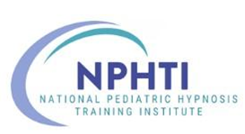
a 501(c)(3) nonprofit educational corporation

National Pediatric Hypnosis Training Institute (NPHTI)
2026-2027 WEBINAR SERIES

Day – Date – Time TOPIC / Learning Objectives FACULTY & MODERATOR

3rd Tuesday  September 15, 2026  11:00 a.m. – 12:15 pm CDT | Title:  Hypnotically Bringing Order to the Habit Disorders  Learning Objectives:  By the end of this webinar, participants will be able to:  - Identify and describe 3 evidence-based hypnotic approaches used in the management of pediatric nocturnal enuresis.  - Formulate a step-by-step clinical treatment plan for pediatric Habit Cough  - Teach pediatric patients 2 self-management strategies to reduce trichotillomania (hair-pulling) and onychophagia (nail-biting). | Speaker: Fred Bogin  Moderator:  Dr. Adam Keating

