Akira Otani, Ed.D., FASCH, ABPH
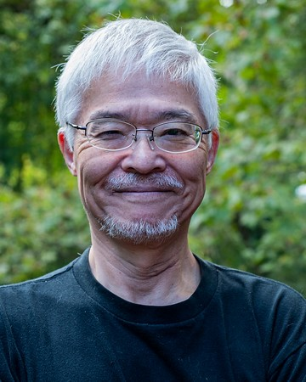
Akira Otani is a licensed psychologist at Waypoint Wellness Center in Maryland, where he maintains a part-time private practice. Before entering private practice in 2008, he served on the graduate faculty at The Johns Hopkins University School of Education (1986–1988) and later as Senior Staff Psychologist at the University of Maryland Counseling Center (1988–2008). A seasoned generalist, Akira has a particular clinical interest in anxiety disorders, including OCD and PTSD.
He integrates hypnosis into his clinical work and remains actively involved in both the American Society of Clinical Hypnosis (ASCH) and the Society for Clinical and Experimental Hypnosis (SCEH). Akira is a Fellow and Approved Consultant of ASCH and holds Diplomate status with the American Board of Psychological Hypnosis (ABPH). In recognition of his teaching, he received the ASCH Presidential Award for Excellence in Teaching. In recent years, he has also developed a strong interest in Buddhist meditation and its integration with clinical hypnosis. Akira is the author of eight books in Japanese and more than 70 journal articles and book chapters published in English and Japanese.
Outside of his professional work, he enjoys spending time with close friends, exploring spicy food, and being around dogs.

