Zoom Guidance and Tips for Attendees of the ASMW 2026 Pre-conference Workshops

Getting Started
- Use the day’s Zoom link from your email or the information page to join the event. You will first enter a waiting room, and staff will admit you when the first session is ready and throughout the day.
- Update your Zoom display name to your first and last name. Right‑click your video tile or click the three dots on your picture and select Rename.
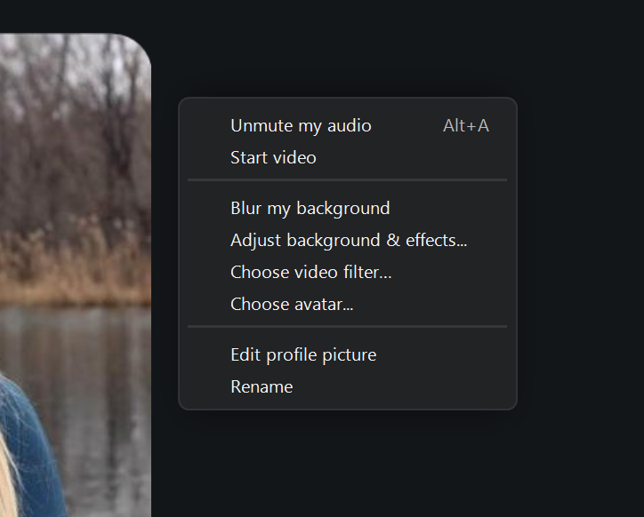

Support During Sessions
- Staff Support: Charlie Healy (Staff) will be available in the zoom and can assist with logistics or technical issues.

Audio and Participation Tools
- Audio Troubleshooting: If you experience audio issues, click the arrow next to the microphone icon to test or adjust your audio settings.
- Reactions: Use the Reactions (heart icon) to raise your hand or share nonverbal feedback. Speakers will provide guidance on how they prefer to take questions and comments.

